**Existing Products & Systems**

1. **2Do: To Do List | Task List**

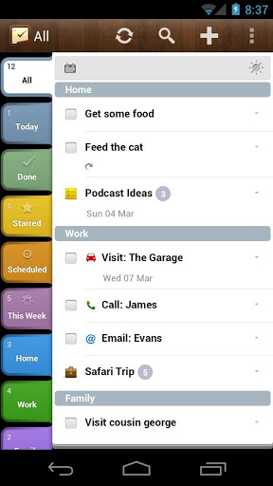 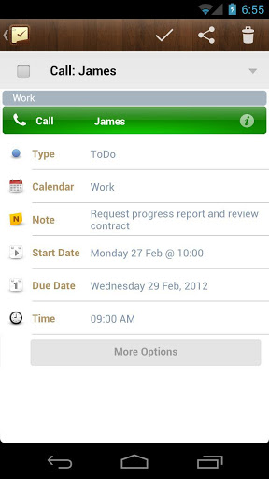

**2Do: To Do List** is a software product from **Guided Ways Technologies Ltd**. 2Do: To Do Listis introduced to be able to run on 3 environments (Android, iOs, Mac OS) and support Smartphone, tablets, Mac computer. 2Do is an incredibly powerful software. This feature-packed productivity app provides everything you need to manage your daily tasks. 2Do includes a helpful tutorial on how to get started. Creating a new to-do list is pretty easy, and the app includes a variety of options for each task. For each item on your 2Do list, you can also add notes, set a due date, tag a location, schedule an alarm, and tack on a URL or photo. You can even make an audio recording with voice notes.

1. **GTasks: To Do List & Task List**

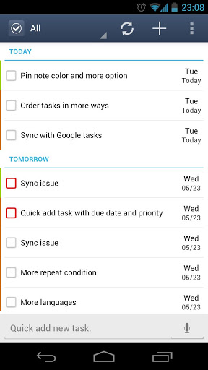

**GTasks** is a software product from **Appest Inc.** Gtask is run only on Android. It support smartphone and tablets. Gtasks is my favorite To-do list app, because it’s  simple and efficient task management. In-app, you can set ring tone reminders, create individual tasks, or categories of lists. You can change the name, color, order of your lists and sync with your google tasks perfectly. With the simple swipe of a finger, you can scroll between the categories, and quickly pull up what you’re supposed to be doing next. The widgets are good-looking, and flexible.

1. **Air To-Do**

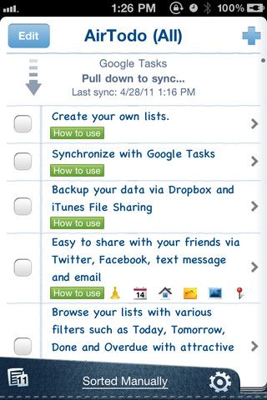

**Air To-Do** is a software product from  AllAboutApps Inc. Air To-Do is run on iOS 3.1 or later. It compatible with iPhone, iPod touch, and iPad. Air To-Do’s interface is very simple, which is a plus for a list app. For each individual item, you can add a due date, set an alert, add a URL or photo, write a note, or tag a location. Air To-Do also includes plenty of sharing options, including the ability to send items via email or text message. One thing I really like about the Air To-Do app is its integration with Facebook and Twitter.

1. **Limitations of the existing products and systems**

|  |  |  |  |
| --- | --- | --- | --- |
| **No** | **ProductName** | **Limitations** | |
| **Features** | **User Interface** |
| 1 | 2Do: To Do List | Task List | Not support drag and drop tasks | Slightly confusing at first |
| 2 | GTasks: To Do List & Task List | -Cannot create Multi task  - Haven't task categories | Not show due time |
| 3 | Air To-Do | -No option to sort or reorder list  -Only one list | Display too simple and too little information |

1. **Advantages of our new system**

- Developing base on cloud computing

- Can share task to other people

- Members can communicate via messaging system

- Support drag and drop tasks.